**Coding challenge**

**SQL**

**Name: Rohan Vinayak Chaudhari**

**Batch: Data Engineering 1**

**Question1: Execute OVER and PARTITION BY Clause in SQL Queries , creating subtotals &Total Aggregations using SQL Queries.**

**1)Create database & using it:**

**Creates a database named coding_challenge_1.**

**Switches to using the newly created database.**

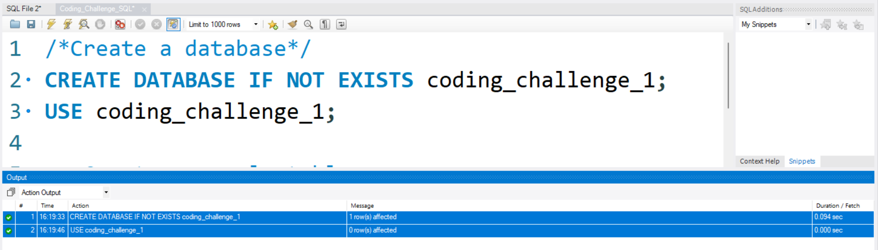

**2)Creating table Order:**

**Creates a table named orders with columns order_id, customer_id, order_date, and order_amount.**

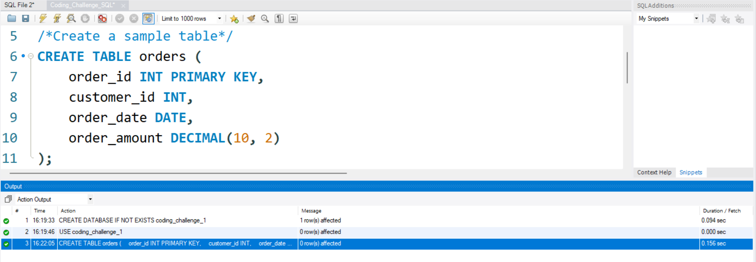

**3)Inserting data into order table**

**Inserts sample data into the orders table.**

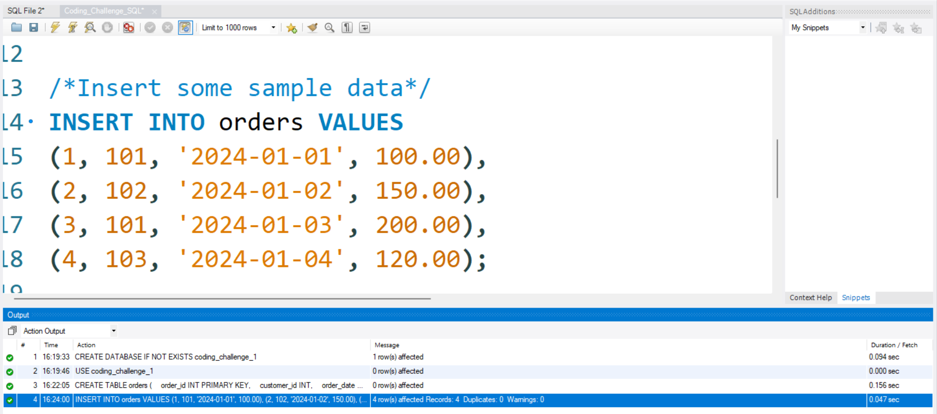

**4) Execute OVER and PARTITION BY Clause in SQL Queries**

**Use of the OVER and PARTITION BY clauses with the SUM aggregation(window)) function to calculate the total order amount for each customer.**

**The query calculates the total order amount for each customer using the SUM window function with the OVER and PARTITION BY clauses.**

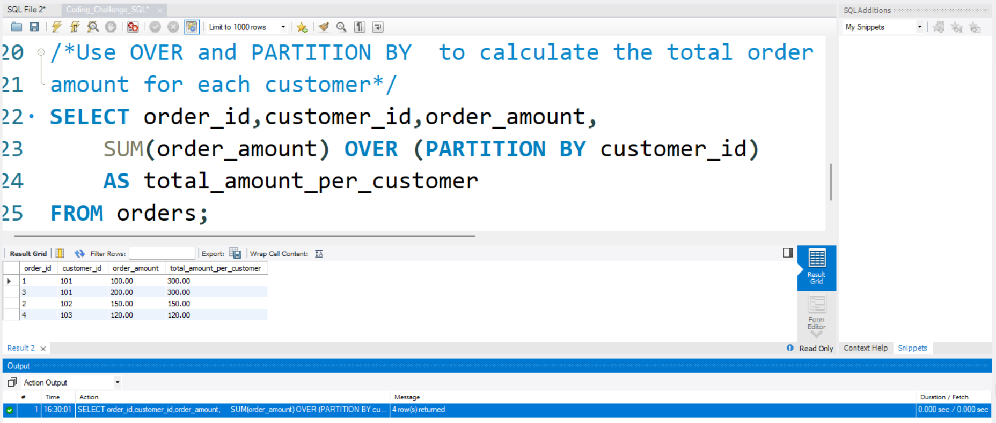

**5) creating subtotals &Total Aggregations using SQL Queries.**

**This query is useful for obtaining a summary of total order amounts, total orders, and average order amounts, min, max amount for each customer, along with subtotals and a grand total.**

**GROUP BY: A clause used in SQL to arrange identical data into groups. In this query, it groups rows based on the customer_id column.**

**SUM(): An aggregate function that adds up the values in a specified column. Here, it calculates the total order amount for each customer.**

**COUNT(): An aggregate function that counts the number of rows in a result set. In this query, it counts the total number of orders for each customer.**

**AVG(): An aggregate function that calculates the average of values in a specified column. Here, it computes the average order amount for each customer.**

**MAX(): An aggregate function that calculates the MAX of order value for a particular customer id. Here, it computes the average order amount for each customer.**

**MIN(): An aggregate function that calculates the MIN of order value for a particular customer id. Here, it computes the average order amount for each customer.**

**WITH ROLLUP: An extension to the GROUP BY clause that includes extra rows that represent subtotals and a grand total. The subtotals are generated for each level of grouping specified in the GROUP BY clause.**

